**Year 10**

**IST**

14

**St. Joseph’s College**

Project Plan

Jordan Lewis

My plan for the Year 10 Semester 2 IST Major Project.

08

**Fall**

Table of Contents

Project Intentions 3

Project Goals 3

Visual 3

Inspiration 3

Goal 3

How 3

Colors 3

Why 3

Content 4

Goals 4

How 4

Why 4

Code 4

Goals 4

How 4

Why 4

Project Storyboard 5

Project Checklist 6

Project Plan Gantt Chart 7

Actual Progress Gantt Chart 7

# Project Intentions

To create a visually appealing, market/internet ready website with valid and accurate information on computer hardware.

# Project Goals

## Visual

### Inspiration

The visual appearance of this website is inspired by Keyners’ Freebee. Link here: <http://keyners.pl/freebie/website-html5-css3-jquery>

From the above template, I plan to take the colors, fonts, header, and footer, but with my own modifications to them. I love open-source.

### Goal

Unified, simple, flat design, appealing to eye, consistent color scheme, easily legible text.

### How

To be able to do this, the use of gradients and images will be made minimal and for the most part, simple flat colors that compliment each other will be used. By strictly sticking to a color scheme (below), it make the whole experience of using the website more unified and appealing. Text will be made easily legible by having colors that stand out, such as white text on orange and black/very dark grey on a very light grey.

### Colors

Colors for the website:

* Orange: #ff6a00
* Lighter Orange: #ff7a00
* Darker Orange: #df4a00
* Gray: #f6f6f6
* Lighter Grey: #f9f9f9
* Darker Gray: #585858
* White: #ffffff

### Why

Users often dislike websites that do not look good, appealing, or modern, this can mean less hits online or less overall usage. By having a flat, modern website, you can decrease the load time due to less images being loaded at once (background images), which can make a website seem very professional.

## Content

### Goals

* To have accurate information of up to date computer hardware, and to be easily understandable by any layperson while containing technical terms.
* To be up to the exceptional level of content.

### How

To have accurate and relevant information on computer hardware, I will use up to date, recent websites to source my information.

### Why

Websites that do not have accurate or relevant information in anyway shape or form are usually disregarded and ignored. This is especially true in the ever-evolving world of technology; staying up to date is very important.

## Code

### Goals

* To be well formatted and be easily understandable by any web developer.
* To be up to the exceptional level of HTML and Related Coding Skills.

### How

I will have well formatted code by using indenting levels, and comments.

### Why

It is very important to have well formatted code to make both your life and another person’s life easier when editing your code. This is especially true in the open source world where there is a possibility of having many developers reading your code. In that case, it would also be a good idea to document your code and any issues relating to it.

# Project Storyboard

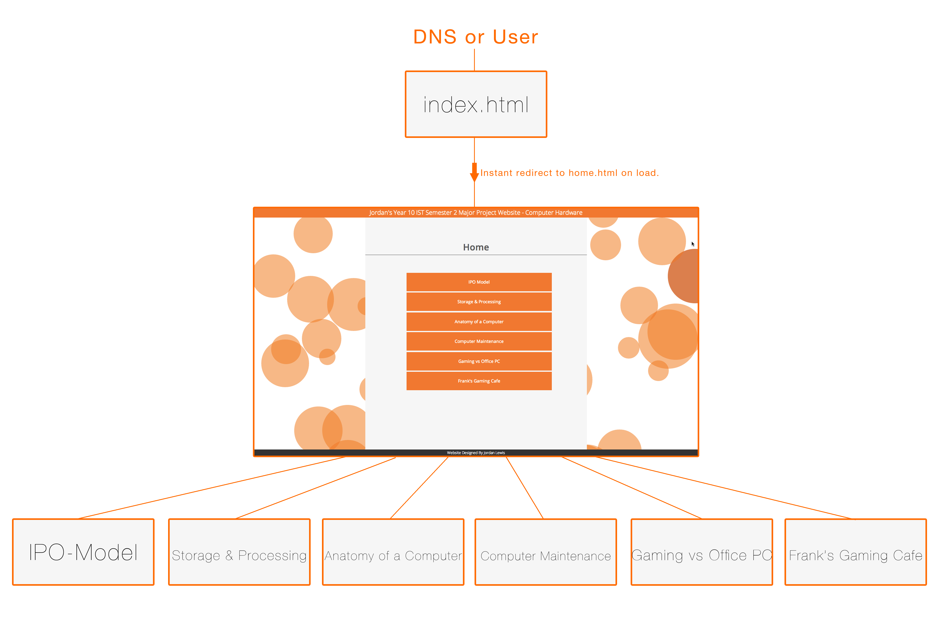

# Project Checklist

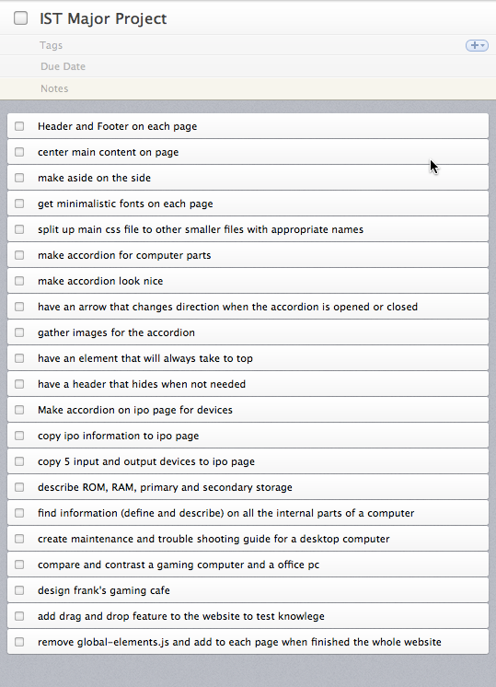

# Project Plan Gantt Chart

# Actual Progress Gantt Chart